Task 1:
Ctext-2 Monoalphabetic cipher
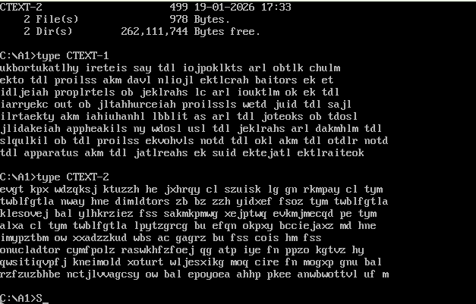
Frequency analysis:
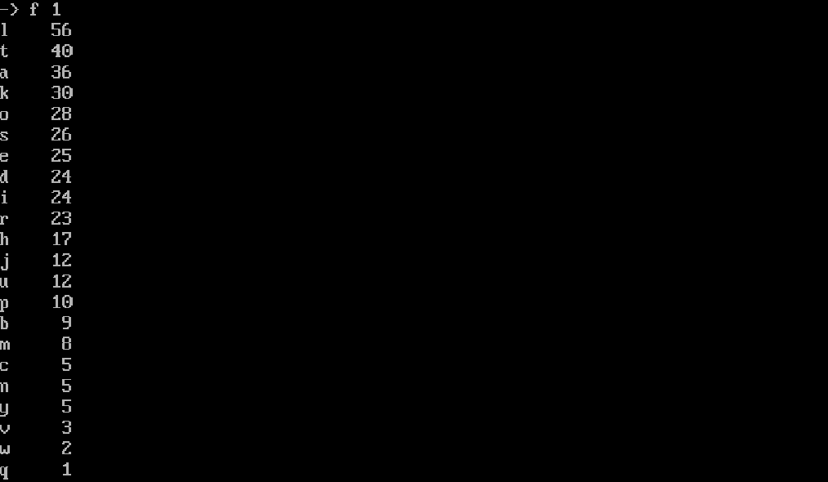
Frequency analysis showed that letter ‘L’ had the highest occurrence (56), followed by ‘T’ (40) and ‘A’ (36). This match expected English frequency distribution where ‘E’, ‘T’ and ‘A’ are most common letters. Therefore ‘L’ was initially mapped to ‘E’.

Substitution testing:
ukbortukatlhy ireteis say tdl iojpoklkts arl obtlk chulm
ekto tdl proilss akm davl nliojl ektlcrah baitors ek et
idljeiah proplrtels ob jeklrahs lc arl iouktlm ok ek tdl
iarryekc out ob jltahhurceiah proilssls wetd juid tdl sajl
ilrtaekty akm iahiuhanhl lbblit as arl tdl joteoks ob tdosl
jlidakeiah appheakils ny wdosl usl tdl jeklrahs arl dakmhlm tdl
slqulkil ob tdl proilss ekvohvls notd tdl okl akm tdl otdlr notd
tdl apparatus akm tdl jatlreahs ek suid ektejatl ektlraiteok

Trigram analysis:
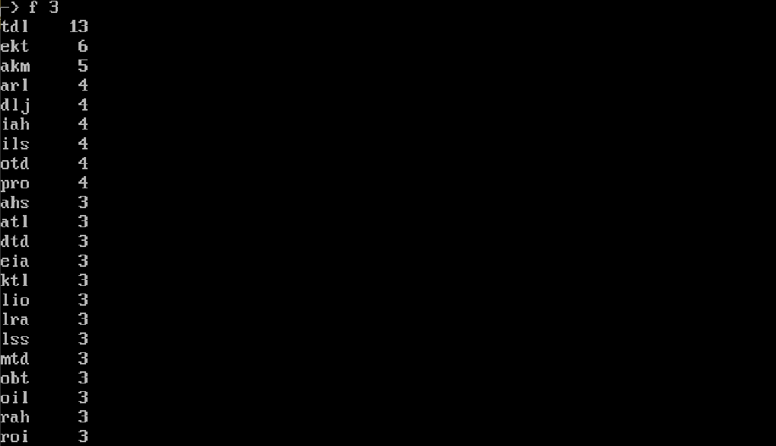
Assuming l -> E, t-> T because letter ‘L’ had the highest occurrence (56), followed by ‘T’ (40) and statistic of English language shows that ‘e’ has the highest frequency followed by t,a,o,i,n,s,h,r. So we can conclude that tdl -> tde.
Again, Assuming that d - > H because the most frequent trigram is ‘the’ and ‘d’ has an occurrence of 24 times. Therefore:
t-> t
d -> h
l -> e

The ciphertext word "akm" appears frequently and occurs as a standalone trigram separated by spaces. In English, common trigram that appear frequently include "the" and "and". Since "the" was already assigned to another pattern, "akm" was tested against "and". This mapping was consistent with surrounding word structures and produced meaningful partial plaintext. Therefore:
a -> a
k -> n
m -> d

Since we know a -> a, l -> e. We can conclude that “arl” is “are”. Therefore:
r -> r

After identifying common trigrams, the mappings tdl -> ‘the’ and akm -> ‘and’ and arl -> ‘are’ were applied to the ciphertext. The resulting partial plaintext revealed meaningful English structure and grammar patterns, validating the correctness of the initial frequency-based assumptions.

ukbortukatlhy ireteis say the iojpoklkts are obtlk chulm
ekto the proilss and davl nliojl ektlcrah baitors ek et
idljeiah proplrtels ob jeklrahs lc are iouktlm ok ek the
iarryekc out ob jltahhurceiah proilssls wetd juid the sajl
ilrtaekty and iahiuhanhl lbblit as are the joteoks ob tdosl
jlidakeiah appheakils ny wdosl usl the jeklrahs are dakmhlm the
slqulkil ob the proilss ekvohvls notd the okl and the otdlr notd
the apparatus and the jatlreahs ek suid ektejatl ektlraiteok

Bigram analysis:
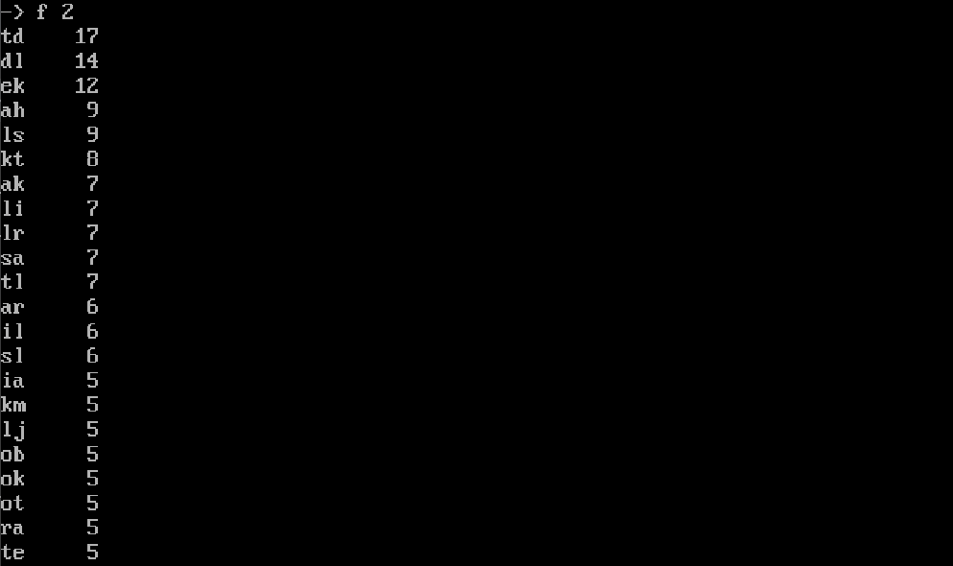

In the ciphertext, “out ob” can be assumed as “out of” because it is a very common fixed expression and appears frequently in english language. Thefore:
o -> o
b -> f

The next ciphertext we can assume is “sajl” with a -> a, l ->e, which closely matches the common English phrase “the same”. Substituting “sajl” with “same” produced grammatically valid sentences and improved plaintext coherence, confirming this mapping. Therefore:
s -> s
j -> m

The next ciphertext we can assume is “ny”. Which closely matches the common English “by ”. Substituting “ny” with “by” produced grammatically valid sentences and improved plaintext coherence, confirming this mapping. Therefore:
n -> b
y -> y

The next ciphertext we can assume is “wdosl” with d -> h, o -> o, s -> s, l -> e. Which closely matches the common English “whose ”. Substituting “wdosl” with “whose” produced grammatically valid sentences and improved plaintext coherence, confirming this mapping. Therefore:
w -> w

The next ciphertext we can assume is “wetd” with w -> w, t -> t, d -> h. Which closely matches the common English “with”. Substituting “wetd” with “with” produced grammatically valid sentences and improved plaintext coherence, confirming this mapping. Therefore:
e -> i

The next ciphertext we can assume is “suid” with s -> s, d -> h. Which closely matches the common English “with”. Substituting “suid” with “such” produced grammatically valid sentences and improved plaintext coherence, confirming this mapping. Therefore:
e -> i
Then “juid” will also be “much” because j -> m

With all of these records, we can conclude that “proilss” is “process” with r ->r, o ->o, l -> e and s ->s. Therefore:
p ->p
i -> c

The next word is “proplrtels”. We can conclude that “proplrtels” is “properties” with r -> r, o-> o, l -> e, t -> t, e -> I, s -> s and p -> p.

The next word is “slqulkil”. We can conclude that “slqulkil” is “sequence” because it appears in the phrase “slqulkil of the proilss”, which matches the common technical phrase “sequence of the process”. This substitution produces a meaningful and grammatically correct sentence and is consistent with the surrounding context.

The next word is “ekvohvls”. We can conclude that “ekvohvls” is “involves” with e -> I, k -> n, v -> v, o ->o, l -> e and s -> s. Therefore:
h -> l
v -> v

A | B | C | D | E | F | G | H | I | J | K | L | M
a | f |  | h | i |  |  | l | c | m | n | e | d
N | O | P | Q | R | S | T | U | V | W | X | Y | Z
b | o | p | q | r | s | t | u | v

With this table, we can transform the c-text1 into:
Unfortunately critics say the components are often clued
into the process and have become intecral factors in it
chemical properties of minerals ec are counted on in the
carryinc out of metallurcical processes with much the same
certainty and calculable effect as are the motions of those
mechanical appliances by whose use the minerals are handled the
sequence of the process involves both the one and the other both
the apparatus and the materials in such intimate interaction

From this partial plaintext, we can conclude that “c” is “g” because of “carryinc”.
Therefore:
c -> g

Key:

A | B | C | D | E | F | G | H | I | J | K | L | M
a | f | g | h | i | j | k | l | c | m | n | e | d
N | O | P | Q | R | S | T | U | V | W | X | Y | Z
b | o | p | q | r | s | t | u | v | w | x | y | z

Plaintext:
Unfortunately critics say the components are often clued
into the process and have become integral factors in it
chemical properties of minerals e.g. are counted on in the
carrying out of metallurgical processes with much the same
certainty and calculable effect as are the motions of those
mechanical appliances by whose use the minerals are handled the
sequence of the process involves both the one and the other both
the apparatus and the materials in such intimate interaction

Ctext-2 Vigènere cipher: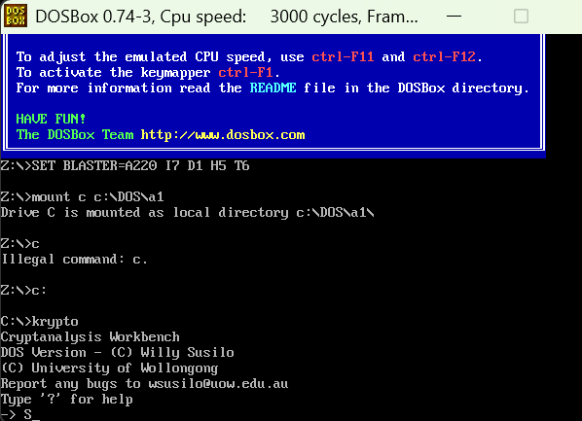
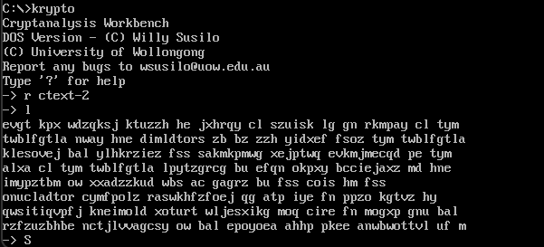
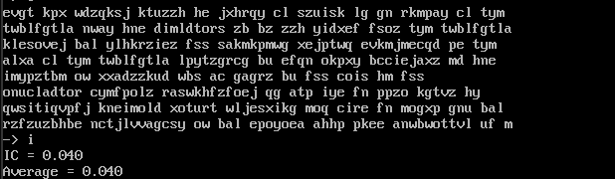
When p = 1
IC = 0.040

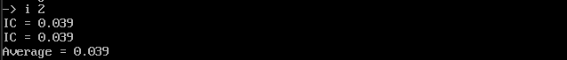
When p = 2
IC = 0.039

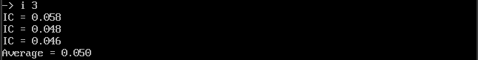
When p = 3
IC = 0.050

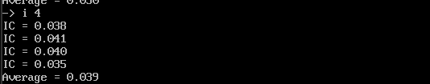
When p = 4
IC = 0.039

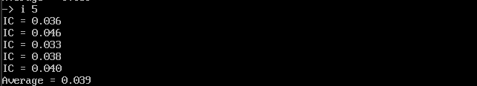
When p = 5
IC = 0.039

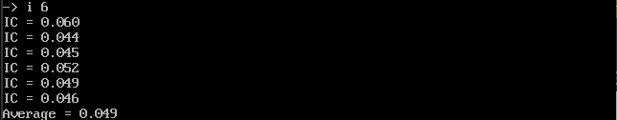
When p = 6
IC = 0.049

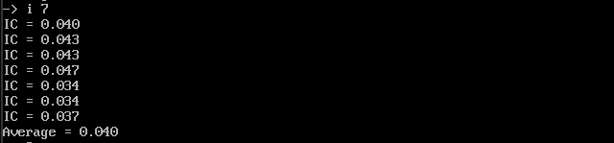
When p = 7
IC = 0.040

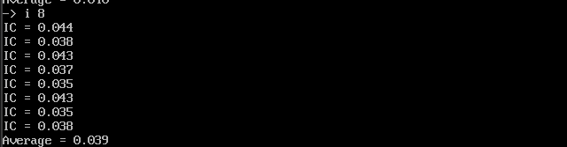
When p = 8
IC = 0.039

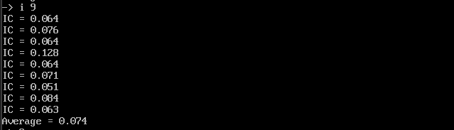
When p = 9
IC = 0.074

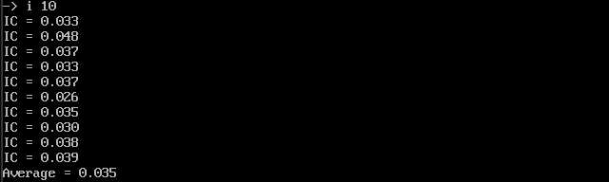
When p = 10
IC = 0.035

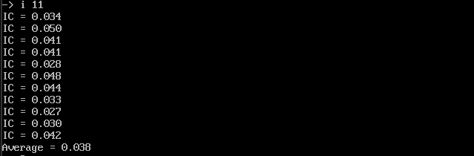
When p = 11
IC = 0.038

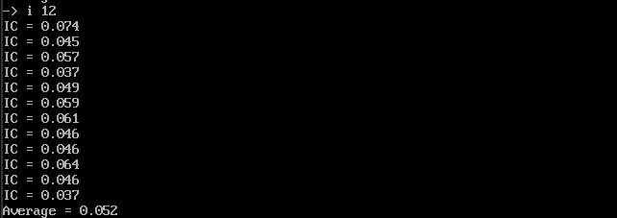
When p = 12
IC = 0.052

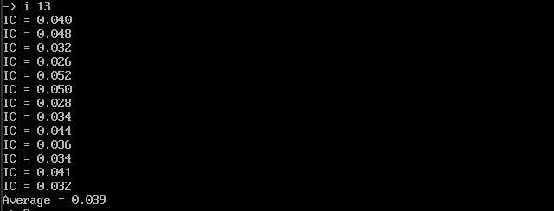
When p = 13
IC = 0.039

According to IC results, p = 9 is the closes to plaintext IC 0.065 to 0.070

G1: ezzyl ytyt ttmw ycwl ezaa azhx zkwh bwdz ptts hfai epbe zskd enqz cnxq lbgn nsga bbls nypt aiae iexr ptoy pae

G2: vqhc gccp fykz kqcc mxei iqjf qzhm mfja pqtj yftt zprt zqhy iill wkee aotm wgtg moxt fhlt qypg ofqn oe

G3: gkh lg lae hlbx ezgj qsyi gmsl mkgl aksk zhsf igpn ceir rtgv vvzz tiiq nsmt uiwt zqqo rzrh tf

G4: tses nttl szep eyez ztrc zlzs kmek ebeo otfd hkzp muao olpm mthe tscs yzov wqox drwp bjq

G5: kjjz ryys jblz ktif hsfm mmpc zubw kczl nrzx gjkj zusq jkec ftdp pfew axrx dwoe pjl

G6: pkxu kmkm xxvm oqtf sspg omqc zpcq sjyh eczg fnkc swlj vrzc kcee wyvt eqrr ush

G7: xth imhh muem tgkw mpoq jyyh vczl vbzr xsfo ozeo qozg pwok rbko rjkz zo

G8: wurs pufr sscp hfsz itow aoyd jlrb ghkv tgpo nwvn klvz wogp wvwl lc

G9: dzqk aqz hqae esd rldx epeq jtac qnva anga ueuf tqcn hvma jzql eea t

Frequency Graph of G1:
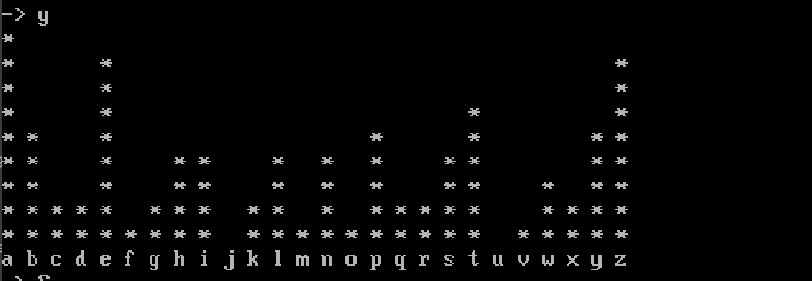
Group 1 most frequent = A (0 in A=0..Z=25).
Key letter = (0−4)mod 26=22(0−4)mod26=22 → W

Frequency Graph of G2:
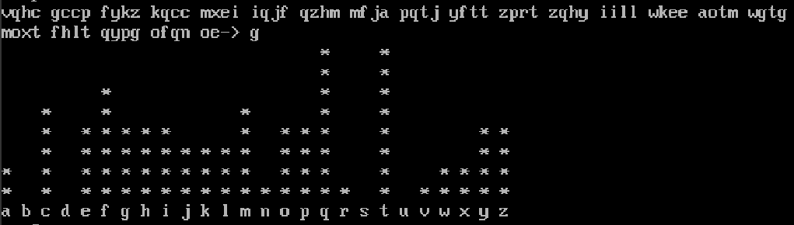Group 2 If most frequent = Q (16 in A=0):
Key = 16 - 4 = 12 → M.
If most frequent = T (19):
Key = 19 - 4 = 15 → P.

Frequency Graph of G3:
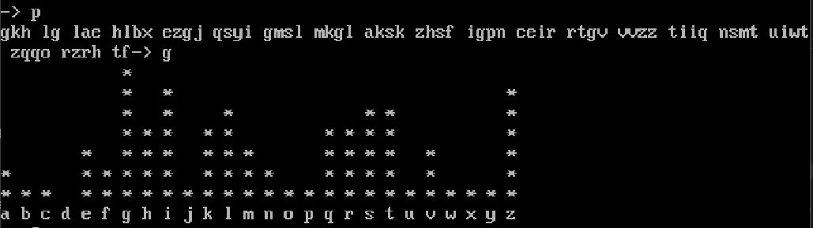
Group 3 most frequent = G (6 in A = 0)
Key = 6 – 4 = 2 -> C

Frequency Graph of G4:
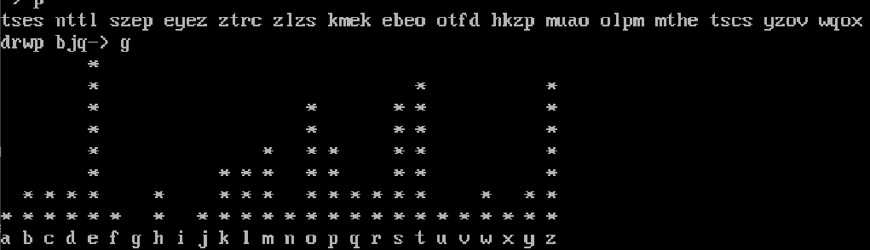
Group 4 most frequent = E (4 in A=0):
Key = 4 - 4 = 0 -> A

Frequency Graph of G5:
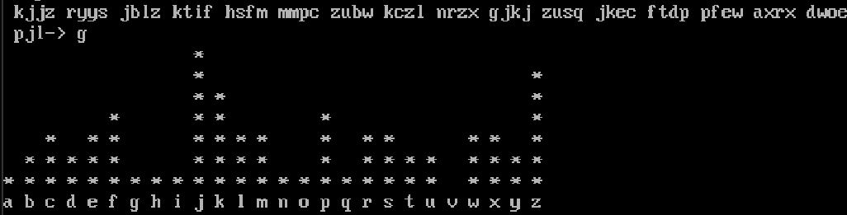
Group 5 most frequent = J (9 in A = 0)
Key = 9 – 4 = 5 -> F

Frequency Graph of G6:
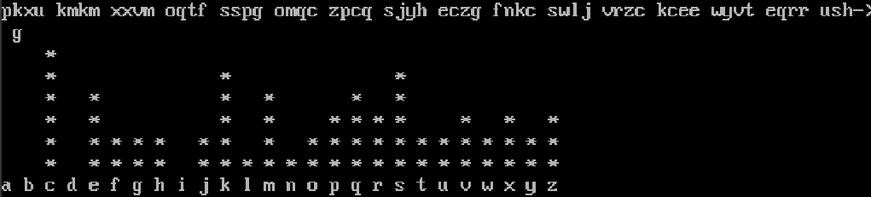
Group 6 most frequent = C (2 in A = 0)
Key = (2−4)mod26=24 -> Y

Frequency Graph of G7:
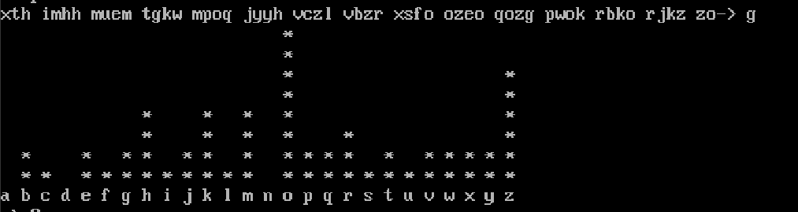
Group 7 most frequent = O (14 in A = 0)
Key = 14 – 4 = 10 -> K

Frequency Graph of G8:
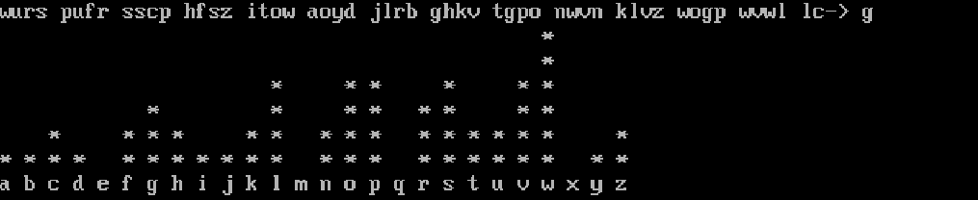
Group 8 most frequent = W (22 in A = 0)
Key = 22 – 4 = 18 -> S

Frequency Graph of G9:
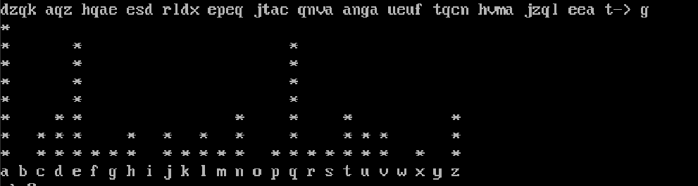
Group 9 most frequent = A (0 in A = 0)
Key = (0−4)mod26= 22 -> W

Therefore keyword: WMCAFYKSW or WPCAFYKSW

Key: WMCAFYKSW
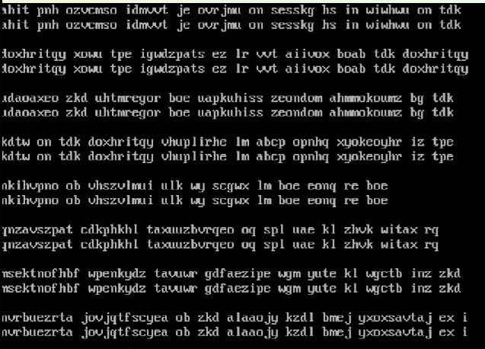

Key: WPCAFYKSW
